**Client: AlcoBrew Distilleries India Pvt. Ltd**



**Business Description**:

AlcoBrew's company vision is to create innovative and profitable brands that exceed their customers' expectations and inspire the spirit of life and to be a company that values its employees and customers. They are involved in large scale production and distribution of in-house and internationally recognized high-quality brands like Old Smuggler, Golfer's Shot, Lion Daddy, and Victorio from their manufacturing facility. AlcoBrew's growth and success has been recognized by Drinks International, Spiritz Selection, and India Spirit Awards.

**Current Status**:

Data is currently stored and collected through a mixture of excel spreadsheets and 3rd party ERP solutions to streamline production processes. Integrating enterprise resource planning with the distribution branch of the company would be optimal for operations and financial planning. This way, data can be readily retrieved and analyzed by anyone in the company.

**Description of the dataset:**

1. Vendor data: This dataset contains the ID and name of the vendors who sell their product to AlcoBrew Distilleries.

2. Transaction data: This dataset contains the transaction details of AlcoBrew. It includes the vendor ID, receipt number, RCPT quantity, value, order number, and order date.

3. Material information data: This dataset contains the description, rate, type, and size of the product.

4. Material type data: This dataset contains the material type details. It has information of the various materials used by AlcoBrew to package and sell their products.

5. Material size data: This dataset contains information about the different bottle sizes sold by AlcoBrew Distilleries.

6. Packaging information data: This dataset contains information about the vendor ID, material type and description of the product.

7. Time data: This dataset contains the transaction data for AlcoBrew Distilleries.

8. Vendor location data: This dataset contains the vendors locations with their zipcode and the information about when they were active since.

9. Location: This dataset contains the location details with zipcode, state and city.

**Project Objectives**:

The objective of this project is to help Alcobrew possess a refined database system that relates tables about location, brand, bottle type, vendors, order quantities, and dates. With an improved information system, data management and analytics will be able to keep pace with the growth of the company and serve its needs as operations expand in scale and reach.

These are some of the questions Alcobrew is trying to find the answers for:

1. The total number of vendors types and their transaction value, which would help them know the most important vendor types.

2. The quarterly breakdown of packaging costs.

3. The total number of transactions based on the number of receipts broken down by quarter.

4. The total cost of transactions divided by city and state. This would help them to know the areas where the spend is higher.

5. The city and state of each vendor to keep track of the supply chain.

6. Segregated data for each month and analyze the monthly rise in costs.

7. The aveage transaction cost each year and how pandemic has affected the supply chain.

8. The costliest vendors to work with. This could help them analyze which vendors to negotiate with.

9. The cheapest vendors to work with which would help them to increase profits.

10. The vendors with which the company has done maximum business with since the vendors were active.

**ERD:**

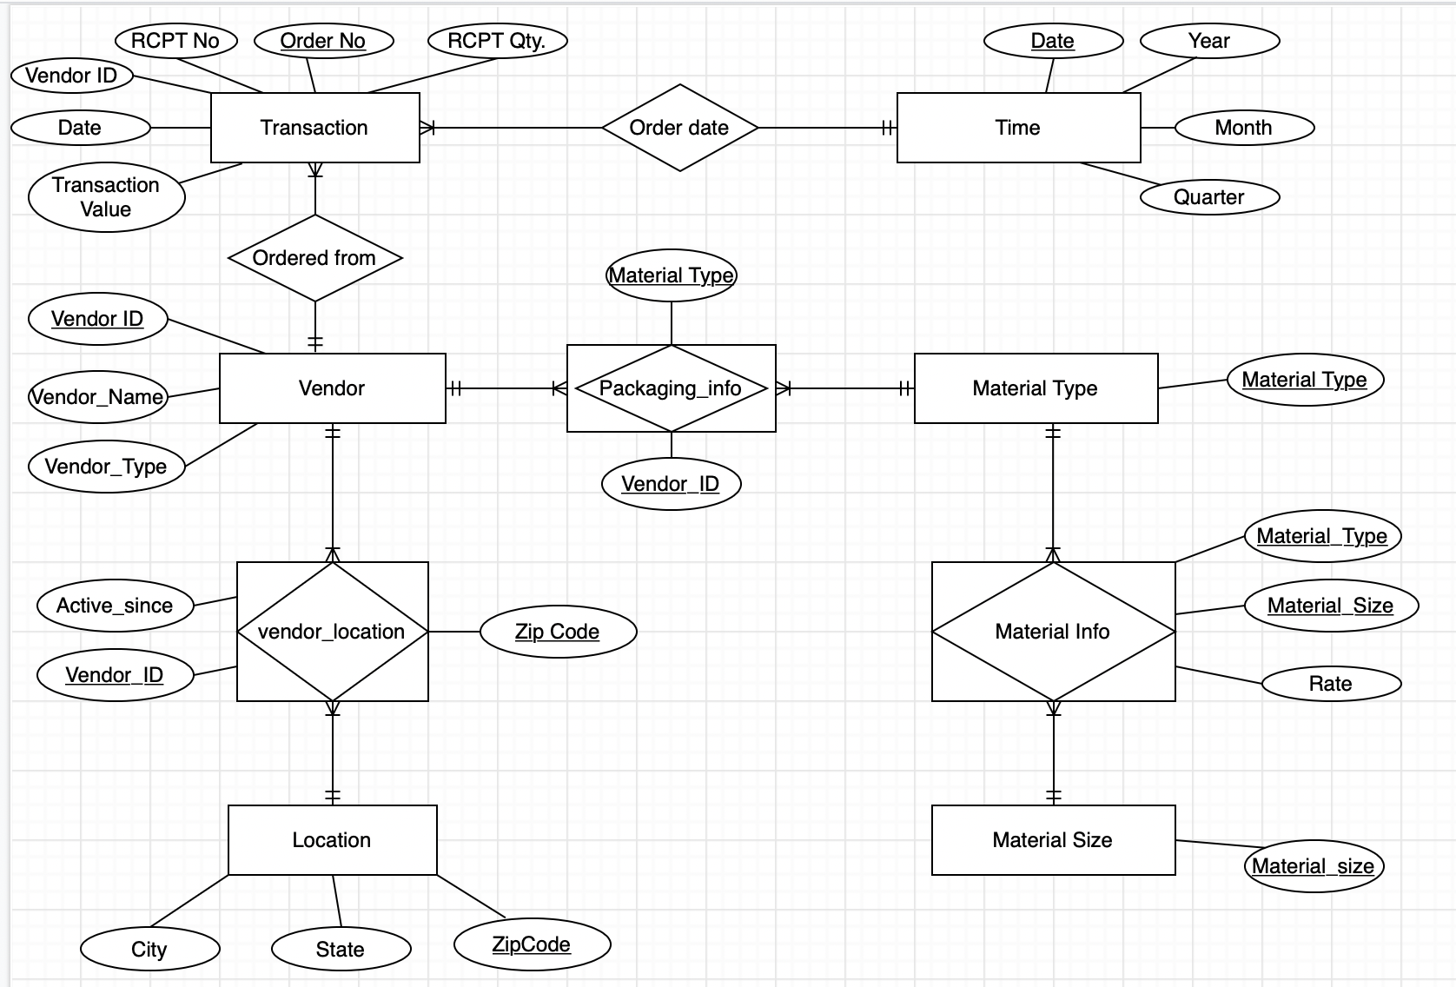

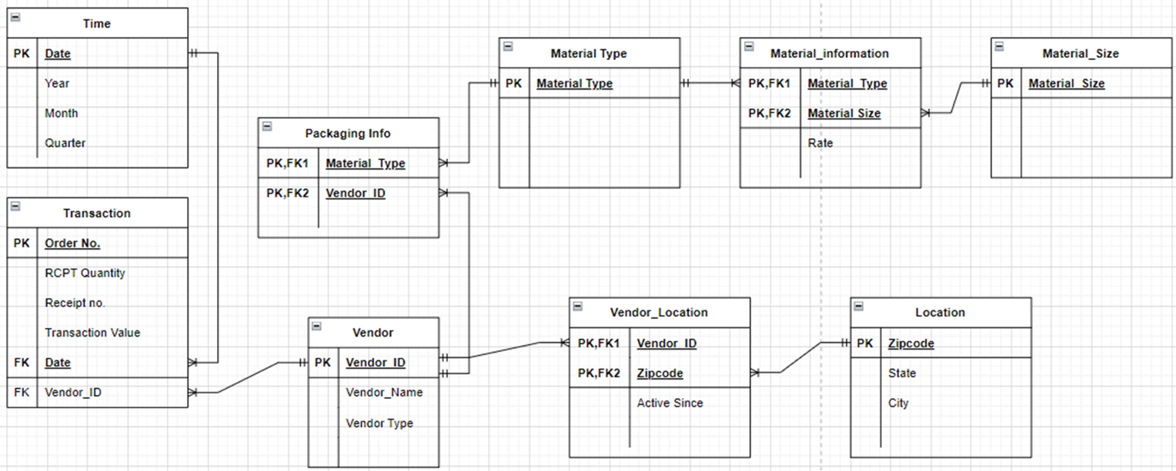

**Relational Schema:**

Vendor (Vendor_ID, Vendor_Name, Vendor_Type)

Vendor_Location (Vendor_ID, Zip_code, Active_Since)

Location (Zipcode, State, City)

Transaction (Order_No, Receipt_No, RCPT_Quantity, Transaction_Value, Date, Vendor_ID)

Material_Information (Material_Type, Material_Size, Rate)

Material_Size (Material_Size)

Material_Type (Material_Type)

Packaging_Info (Vendor_ID, Material_Type)

Time (Date, Year, Month, Quarter)

**Design Choices:**

The vendor table contains information about the vendor which contains vendor id as the primary key. This vendor id is a foreign key in the vendor location, packaging info, and transaction table. The vendor location contains the location details of the vendor and the transaction table contains the transaction details. The packaging info table contains the description of the product.

The time table contains the date information which can be used to infer when the transaction had taken place.

The material type table contains the material type whereas the material size table contains the material size information. These attributes are foreign keys in the material information table which contains the rate.

**Design Description:**

AlcoBrew Distilleries Pvt. Limited worked with various vendors for their product needs. A vendor contains the following attributes: Vendor_ID(identifier), Vendor_Name, Vendor_Type. A vendor can be present in one or many locations, and a location may have zero or many vendors. A vendor can perform one or multiple transactions whereas a transaction can be performed by one and only one vendor. A vendor may have one or more packaging_info, but a packaging_info will have only one vendor.

**Normalization analysis:**

1. The data provided by AlcoBrew Distilleries contained vendor information along with material information in a single dataset. We split the data into two different tables to avoid insertion, deletion or update anomalies.

2. The vendor data was grouped with transaction data in the dataset i.e we had composite transaction values for a single vendor. This data was converted from 0NF to 3NF form. Later, we created a new table with the transaction details to avoid inconsistency in data.